Story and Video by Emily Kennard

Archival Photos provided by Inez Ribustello
“I think life is a lot like wine,” says Inez Ribustello, 39, who was born and raised in Tarboro, a small town in eastern North Carolina.
“There are times in your life where you might be in a bad place, and you might not be your best self. Just the same way when you open a bottle of wine that may not be ready, and it doesn’t taste the way it's supposed to taste because it’s not at its prime point. But it softens as it ages.”
Wine has been central to Inez’s life, and she has dedicated her career to the craft. In 2000, Inez scored her dream job as the Beverage Director at Windows on the World, the renowned restaurant located on the 107th floor of the North Tower in the World Trade Center. It’s there that she would meet her future husband and eventual business partner, Stephen Ribustello, get a taste of a luxurious New York lifestyle and learn more about wine than she could have ever imagined.
But on Tuesday, September 11th, 2001, her passion for wine almost cost her everything.
This is a story of how in the face of immense tragedy can come joy, love and new beginnings; and how a small North Carolina town, 475 miles from Manhattan, helped one of its own rebuild out of the ashes.

Beginnings
As a child, Inez dreamt of attending UNC – Chapel Hill. As a freshman there, she walked onto campus ready to pursue a journalism degree.
A junior-year summer internship with Voice of America took her to Washington, DC, where she lived with a relative. In exchange for housing, Inez agreed to babysit and cook for the family. Here she discovered her passion. “I loved [cooking],” she says. “I loved...shopping for ingredients, all of it.”
She abandoned her dream of becoming a news anchor and set her sights on culinary school. While her mom, Mattie Carstarphen, at first said “absolutely not,” her father, Rusty Holderness, always saw a potential chef in his daughter.
Inez promised to graduate from UNC, but as a compromise, was allowed to intern the next summer at a local kitchen in Tarboro. During her senior year at UNC, while working at Fearrington Village in Pittsboro, she was first exposed to fine wine. “They would do a wine tasting for [the staff] every Thursday. It was very professional. You didn’t drink, you spit,” says Inez. “I was in awe.”
While finishing her journalism degree during the day and working on her wine palate at night, Inez was accepted to the Institute of Culinary Education in New York City.
After graduating from UNC, she moved to New York City with five friends from North Carolina and lived in a small apartment in Hell’s Kitchen. Throughout culinary school, she worked at a local wine shop, Best Cellars, where no bottle cost more than $10.
“Wine was really one of the only things I had that was my own. Nobody in my family was doing it.”
— Inez
After culinary school, Inez was hired as assistant cellar master at Windows on the World in April of 1999. By the next year, she was promoted to Beverage Director, overseeing one of the most expansive wine programs in New York City.
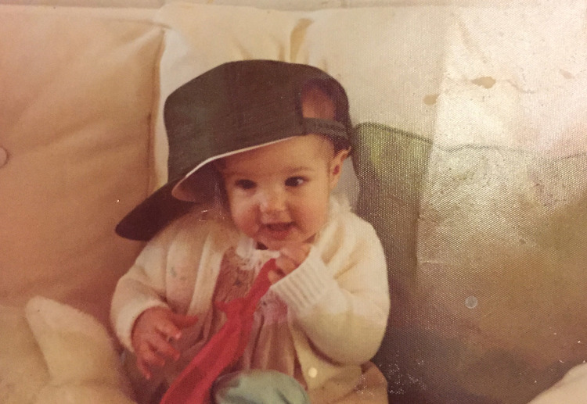
A young Inez in Tarboro, NC
Inez prepares a James Beard Dinner, fine-tuning her culinary skills after graduating from the Institute of Culinary Education
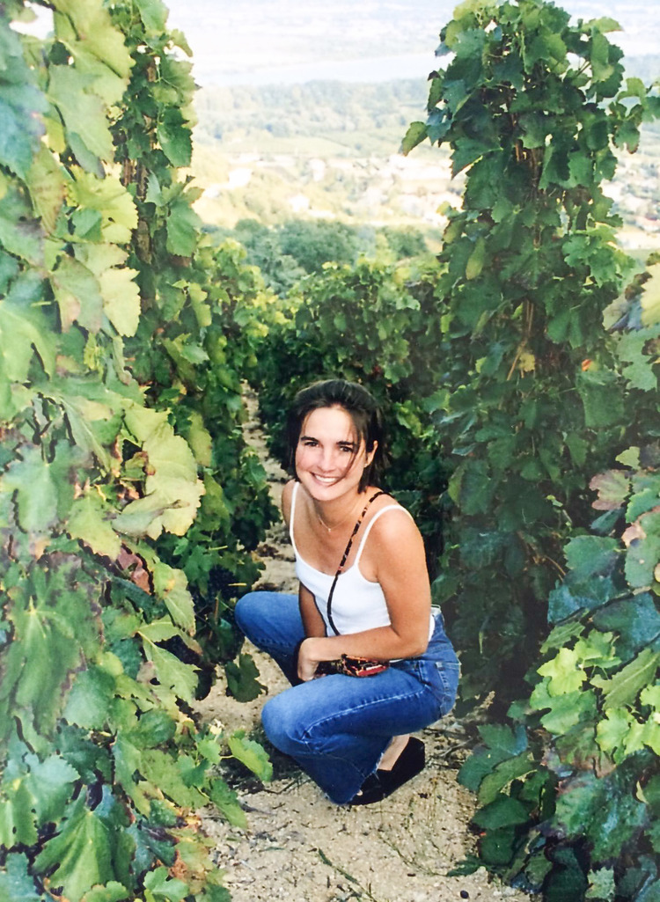
Inez at a vineyard in Condrieu, France

Up North
As an 18-year-old community college student, Stephen Ribustello worked as a restaurant server in upstate New York, spending as much time in the kitchen as he could. There, he learned how to cook professionally and began his love affair with wine. A chef, who had inherited a wine cellar, began to teach Stephen about it.
“Here I am, at 18-years-old, drinking first growth Bordeaux. I had no idea. I didn’t know what I was drinking. I knew that French wine was often more expensive and better. That’s all I knew.”
— Stephen
Stephen, now 39, transferred to North Arizona to study environmental engineering and took a job at a local French bistro. He studied wine in every spare moment, often looking to the Windows on the World Complete Wine Course book. Stephen says he realized, “I really loved wine a lot more than engineering.” His hard work paid off when he was promoted to a resort’s Head Sommelier at the barely-legal age of 22. Soon, Stephen was hired at New York City’s iconic Tavern on the Green, but by the time he arrived in New York City, his new position had been eliminated.
Left in New York with no job, he applied everywhere he could and scored an interview at Windows on the World. Stephen, who says, “I really was under qualified and in over my head, but I just had a great interview,” got the job as a Sommelier at one of the grandest restaurants in New York City, where he would soon meet Inez.
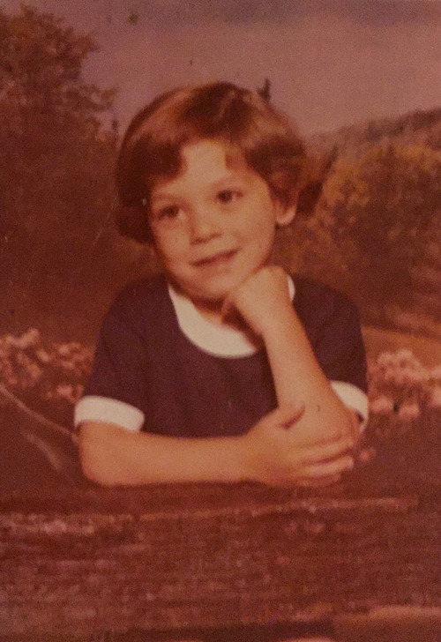
A young Stephen in Monroe, NY
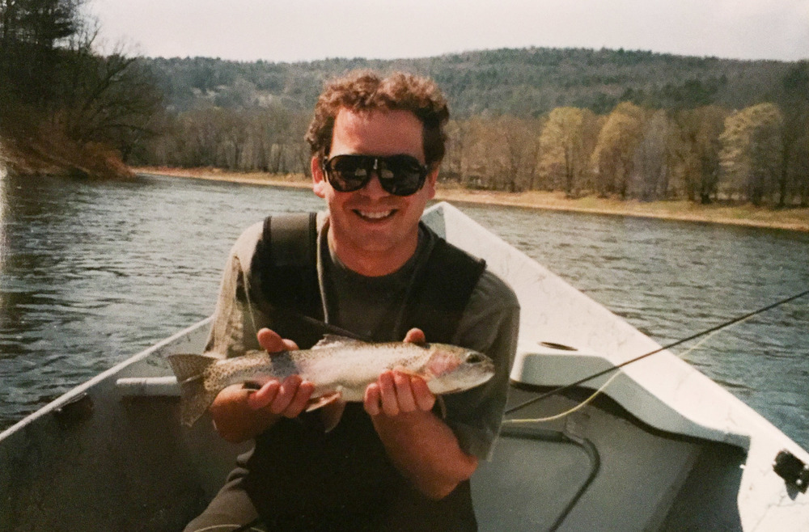
Stephen on a fishing trip in Arizona

The Meeting
Stephen, who began at Windows on the World in March 2000, heard there was a new Beverage Director under whom he would be working. “I asked a co-worker [about the new Director] and she told me, ‘Inez will be the little girl with a bunch of guys around her.’ I was intrigued.”
“When [Inez] first walked in, I was like there’s no way this girl is my boss. She’s tiny, young, cute, [and] southern.”
— Stephen
Although dating fellow staff was prohibited Inez and Stephen were immediately attracted to each other. Inez fondly recalls, “He was super cute with those big eyes. And, he was funny. He was really, really funny.”
After five months of working together, Inez asked Stephen to be her date for an upcoming event. He said yes, under one condition. The Yankees and the Mets were playing in the Subway Series, and he wanted to bring a hand held television to the event. Inez remembers comically, “He basically ignored me, while I drank. He watched [the game] and...was super happy because the Yankees won.”
Their covert romance blossomed and the two were officially a couple one year later in June of 2001.
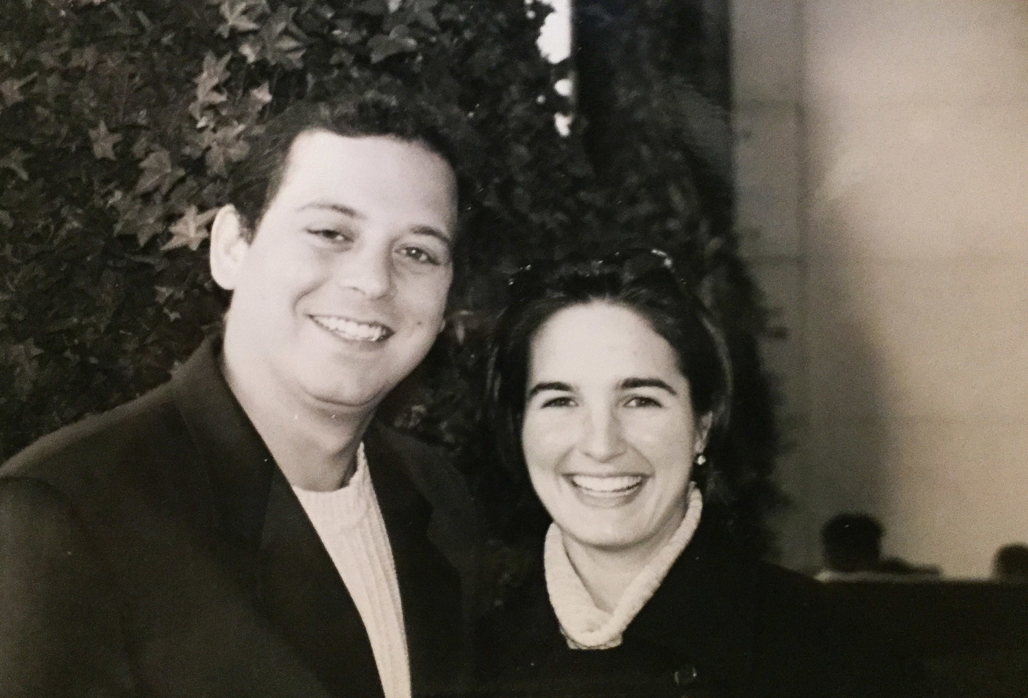
Inez and Stephen met in 2000.

Life On Top
During their courtship and careers at Windows on the World, Inez and Stephen, both only 24-years-old, felt on top of the world. “It was surreal. It was as if there was an infinite amount of money. It was insane,” Inez says. “I was 24-years-old, working on top of the tallest building in the city, in this great restaurant with this awesome wine program” says Stephen.
The couple was regularly invited to six course lunches, limo rides to vineyards in Long Island, and nightly dinners at the best restaurants in the world, accompanied of course, by wine.
“Being spoiled is an understatement. Just completely overindulged. No awareness.”
— Inez
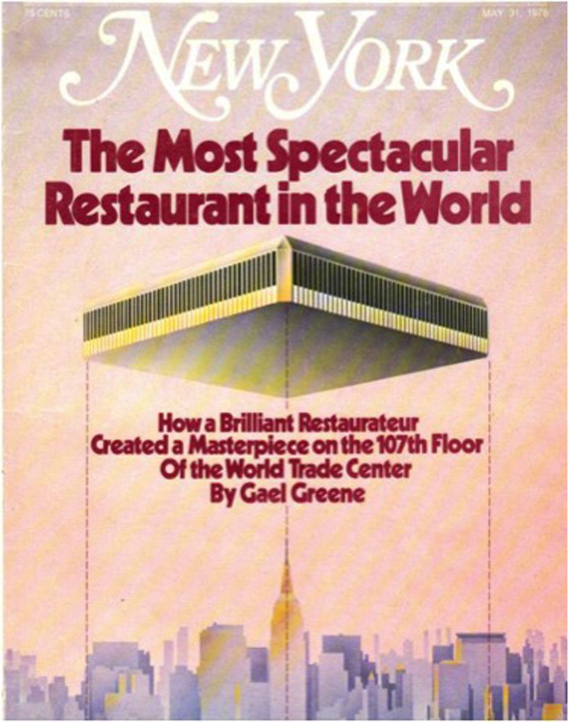
New York Magazine featured Windows on the World on its cover in 1976, the year of its opening.
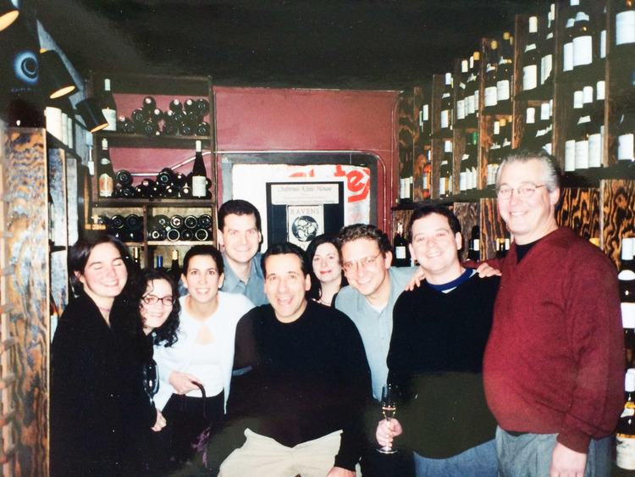
Windows on the World Staff at the restaurant's Christmas party in 2000
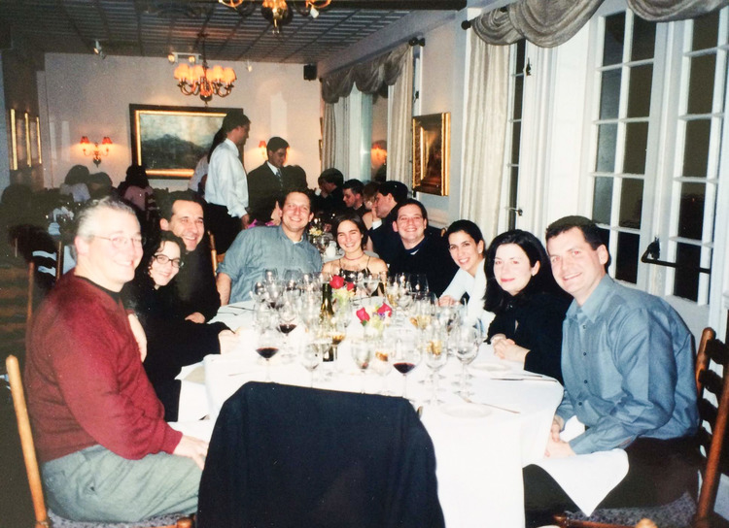
Inez and Stephen celebrating with their co-workers, friends and mentors from Windows on the World.

Awakening
The week before September 11th, Inez found a 3-liter bottle of Mumm champagne that had been stowed away in her office months before. She said to everyone, “When I get back, I’m going to chill this and drink it.” Little did she know, she wouldn’t get the chance.
Inez left Stephen in the city and headed to North Carolina for her sister’s wedding on September 8th. She remembers, “I did, ironically, tell a lot of people goodbye when I left.”
On the morning of September 11th, Inez awoke to her mom standing over her, crying. Her first thought was something had happened with her grandmother. Her mother told her to turn on the TV.
She saw smoke billowing from World Trade Center.
“I was literally watching it and thinking, ‘This is going to take forever to get cleaned up. I wonder when we can get back in. Almost childlike in how naive I was in thinking that no one was hurt on our floor because it didn’t hit on our floor,” says Inez. “And then I watched the second plane come, and I knew. I just sat there and watched them fall.”
— Inez
“I remember watching her watch that TV set,” says her mother. “I didn’t want to let her go. Had it not been for that trip, she would have been in there.”
Inez completely shut down. “I wasn’t crying. I think that was what scared my mom and sister the most... I was almost comatose.”
Back in New York, in the early hours of Tuesday, September 11th, Stephen waited for the 2:30am train back to his Jersey City apartment. He was returning from a New York Giants game with friends and had stayed out late celebrating. The train, which left below the World Trade Center carried him home, where he blasted the window AC unit and hoped to sleep off the night before in time for an 11:00 am wine tasting at Windows on the World.
When he woke up the next day at 10 am, he had 27 messages on his answering machine. His apartment overlooked the Statue of Liberty and the World Trade Center. That morning the view was drastically different. Stephen recalls, When I looked out [to the left], there was nothing there, just smoke.” From his Jersey City apartment, he watched the chaos below.
“It was completely surreal. I walked down to the river and stared across just in disbelief. I had no idea if anyone had made it down.”
— Stephen
With no cell phones or social media, Inez finally managed to get in touch with Stephen via his pager.
79 of their co-workers passed away that day.
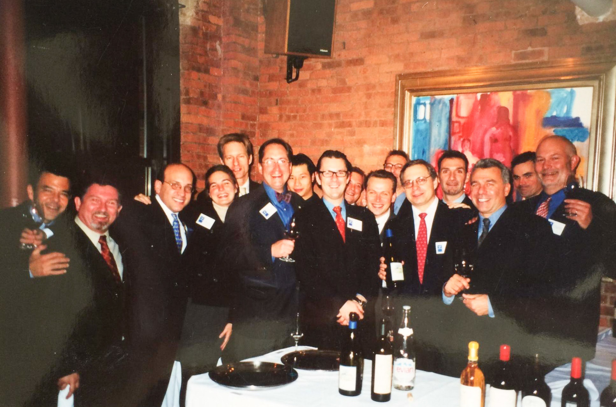
Stephen and Inez gather with other survivors and co-workers from Windows on the World, at a dinner held after 9/11.

Next Steps
Only remnants of the couple’s former life remained.
“You have the job. You’re always thinking about the job and all of a sudden it’s like a light switch. It’s off. And you’re like well what I am supposed to do,” Stephen says. “You have this huge piece of your life completely taken away. I was miserably stunned.”
The couple met in Baltimore a day after the attack, and traveled back to the city several days later where they volunteered at a hotline for missing persons. But after one day, they couldn’t take it any more.
“There was not one single happy story, at least for us. For some lower than us, there were. But not for Windows.”
— Stephen
In the weeks that followed, Stephen found work at a wine shop on the Upper West Side, while Inez took a high-pressure job as a Wine Director for a new restaurant opening in Times Square on New Year's Eve, four months after the attack. “It was probably one of the dumbest things I’ve ever done,” says Inez about taking that job. “I literally cried everyday. That was a time in my life when I was angry at God.”
Despite the hardship, Stephen and Inez’s relationship grew stronger. They moved in together, and in January of 2002, became engaged despite Inez’s parents' uncertainty. They picked out a $500 ring together, declined insurance, and celebrated with a Knicks game, bowling and a meal at their favorite restaurant. “It was a good excuse to have a fun day,” Stephen says.
Despite progress, the trauma of 9/11 persisted. Inez’s anxiety grew worse.
“[What] I couldn’t deal with, was not working with [Stephen]. I was wondering where he was, if he was safe. I had...anxiety from what had happened, and it was compounding.”
— Inez
Finally, Inez’s parents convinced her and Stephen to come home. They packed up a U-Haul and drove south in May 2002.
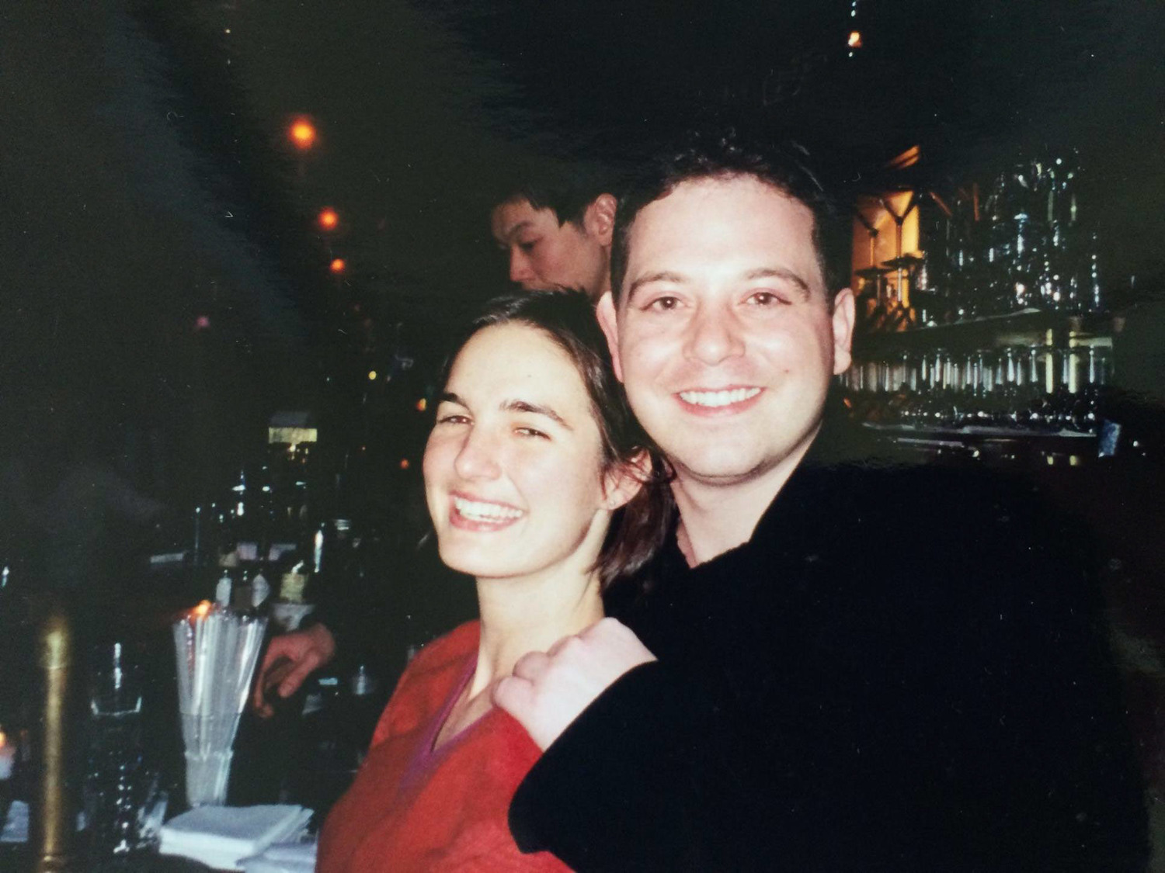
Stephen and Inez on the night of their engagement.

Homecoming
Soon after returning to Tarboro, Inez got a call from Frances Liverman, who was looking to sell her restaurant On the Square.
At the time, “I didn’t have two dimes to rub together,” says Inez and declined her offer. But her father, Rusty, had overheard the call. “I could not have been more excited. I thought it was a good idea,” he says. “I would have been excited if she had bought the city dump.”
Rusty, along with another local investor, were plotting to buy the restaurant. Inez and Stephen knew a conversation “was in the works, but the deal happened much sooner than anticipated.” Rusty called Inez and Stephen, who were on a trip, and said they needed to come home. They returned on a Sunday and the next day were in the On the Square kitchen, which consisted of a stove from 1976 and a Panini press.
In Stephen’s words,“It needed a lot of work.” Living in an apartment across the street, Inez and Stephen went to work, renovating and remodeling the kitchen. The restaurant officially re-opened on October, 17th, 2002.
On the Square’s innovative tapas menu and wine shop brought the couple’s food and wine expertise to a town unaccustomed to fine dining. Frances, who now works as the General Manager of On the Square says she, “Knew with their experience in New York City that they were going to blossom. I think the most important changes they made were to the menu. Tarboro had never had something like that before.”
“People say…[On the Square] is so unexpected with [Tarboro’s] demographics and unemployment and our poverty level. We have a lot of things stacked against us unfortunately,” says Inez. “We had no desire to be super fancy. But I like that the fact that people can come in here and be wowed."
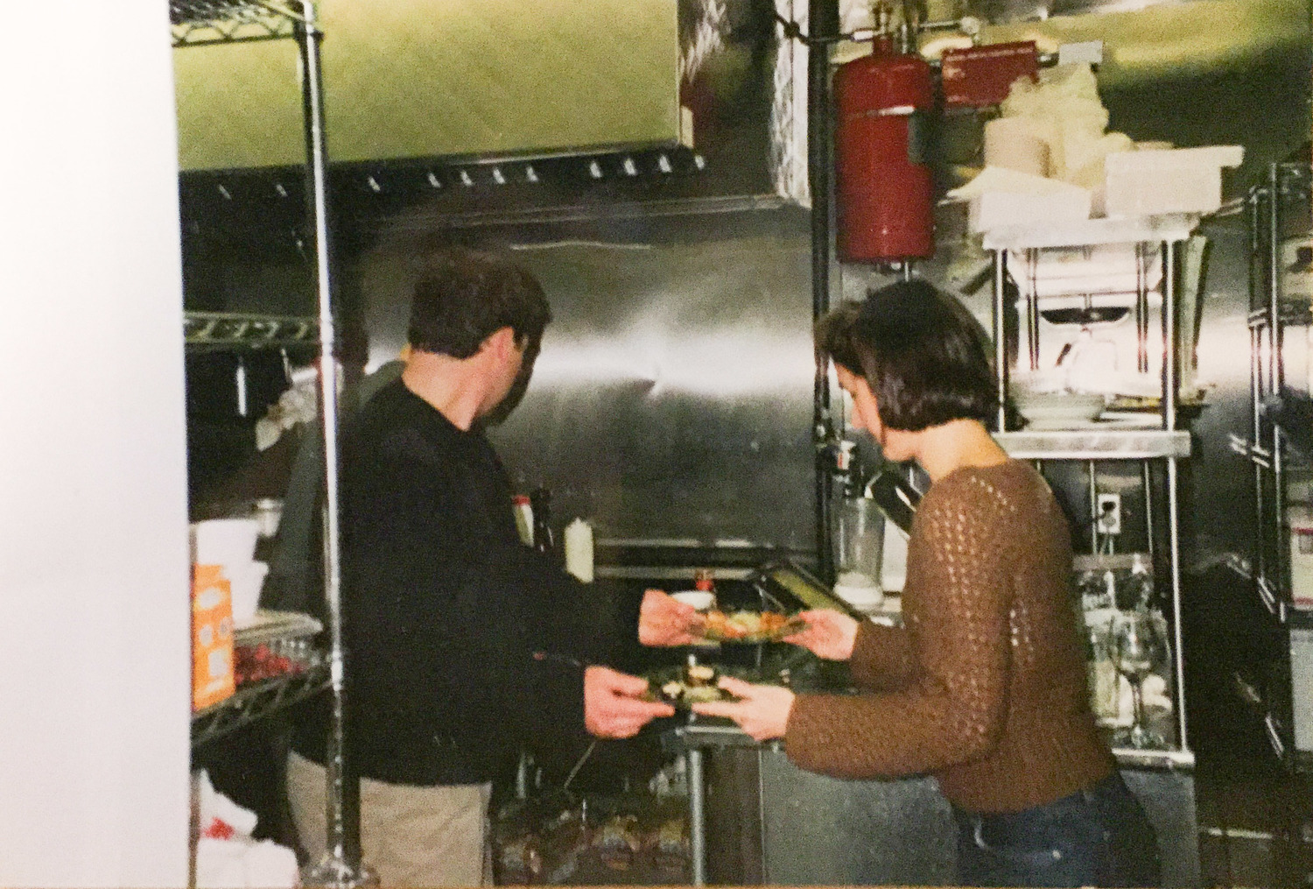
Stephen and Inez working in the kitchen on On the Square's opening night.

Surprises
In March 2003, Inez got a call for a consulting job in Atlantic City that was financially “too good to turn down.”
She agreed to start after her wedding, slated for April.
Stephen and Inez wed in her parents’ house in Tarboro. Co-workers from Windows on the World, Tarboro neighbors and Stephen’s family were all together – this time to celebrate a happy occasion.
“It was like coming out of a long dark storm,” says Inez’s mother. The day after their wedding, Stephen drove Inez to Atlantic City for her new job. She cried the whole way. “I tried to make it like a mini honeymoon and do some stops,” says Stephen, “[But] she really cried every minute of that trip.”
Stephen and Inez made long distance work for a year and a half. Most weeks, Stephen took the train from Rocky Mount and spent Sunday and Monday with Inez. The rest of the week he spent in On the Square with Inez’s father, Rusty, and many from the community of Tarboro.“ It was fun getting to know [Stephen],” says Rusty. “He was the Yankee. We were trying to figure out who he was, and he was trying to figure out who we were.”
Inez was enjoying her job in Atlantic City and planned to stay. They were making long distance work, and Stephen was making his new life in Tarboro.
Then Inez found out she was pregnant.
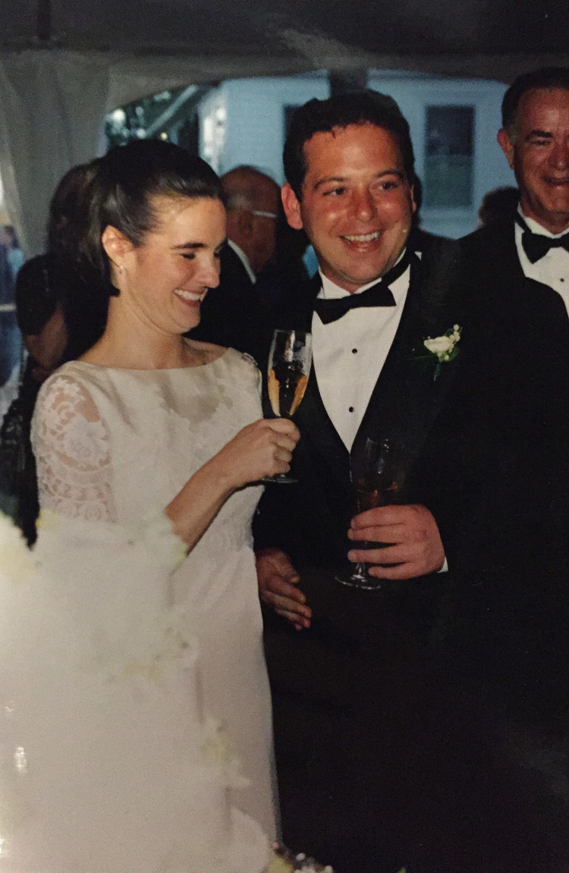
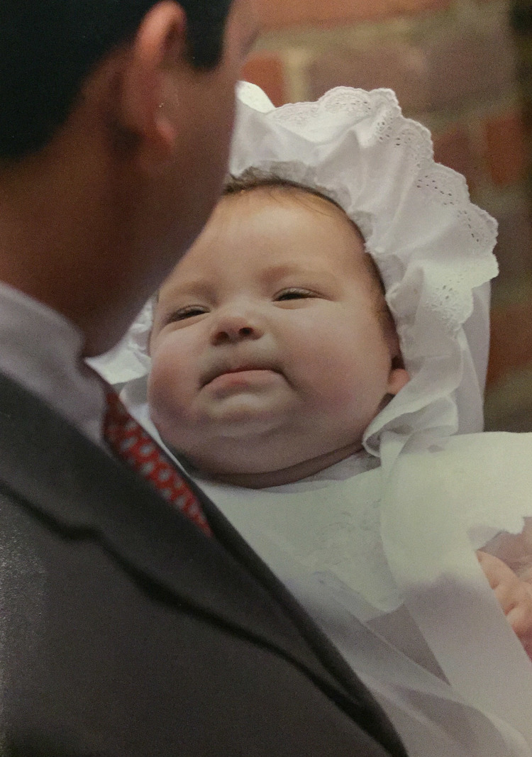

New Life
When Inez moved back to Tarboro, she was amazed at what Stephen had done with On the Square. “He had just done this incredible job of making it a real restaurant.”
“I didn’t think it was going to work. The demographics are terrible when you’re looking at wine-themed high end restaurant using local products,” says Stephen, but “[Rusty] thought it would work. He thought Tarboro needed it. He thought it would be a good place to live. And honestly, he was right.“
This year, On the Square celebrated its 13th anniversary. It has garnered rave reviews, and its popularity is growing.
But maybe most importantly, the community of Tarboro has found a home in On the Square.
“It’s given us an identity. It is it’s own culture,” says Rusty, who still acts as the owner but has minimal involvement in the day-to-day operations. Barbara Getzug, who moved to Tarboro from Pittsburgh, was concerned about fitting in down South. But she found a home at On the Square. “They were very accepting,” Barbara says. “I feel like they’re neighbors. If it wasn’t for On the Square, we would be spending a lot of gas money going elsewhere.”
Bernice Pitt, whose family owns a hardware store down the street, has seen an influx of visitors since On the Square’s rebirth. “It has put Tarboro on the map. I go there on a Saturday night, and I don’t know a daggum soul,” says Bernice. “It brings people to Tarboro who have never been.”
Where hospitality reigns, customers have become an extended family; a philosophy, Inez and Stephen also extend to to their staff, who they mentor and teach. Anthony Burroughs, who started at On the Square as a dishwasher when he was 17-years-old, is now the sous chef. “When I was younger, everyday was a struggle,” he says. “I have learned everything from Stephen. And even more than just cooking, like how a business runs. The biggest thing is having a positive attitude. Have a good attitude and success will come.”
This is what Inez and Stephen strive for – to bring money, jobs, and tourism to Tarboro. “I’m just very proud of what we have to offer, and I just think more people need to know what a great place [Tarboro] is to live,” says Inez. “It’s interesting talking to younger people. They say, ‘Well if I was married, I would come back to Tarboro, but I can’t meet anyone in Tarboro.’ I want it to be [a place] you move back to... so you can meet people.”
And, it seems to be working. Thursday night, which the staff refers to as date night, is usually packed.

Family Life
Stephen and Inez, who celebrated their 13th anniversary this year, have now worked together for 15 years. They are raising two children, and have three sets of grandparents in the area.
Cynthia, 10, their oldest daughter, runs food, works as a server at catering events and even helps her dad out in the kitchen. She will turn 11 on September 12th. “I don’t think it’s a coincidence that Cynthia was born on September 12th,” says Inez. “It’s a beautiful reminder of how we will survive. [I heard] a sermon that you can’t experience God’s Grace until you experience true pain. I think there’s nothing more beautiful to me than celebrating her birthday every year the day after September 11th because it makes September 11th seem that much more bearable.”
Stephen’s mother, Kathy Wheatley, bought a house in Tarboro when Cynthia was born and permanently moved there five years ago from New York. “People were so welcoming and warm. I made a whole new family,” she says. “The best part of being down here is the family. I just love it. I’m never moving back to New York. This will always be my home, despite having no Italian delis.”
Tarboro is Inez's home too. “The beauty of being back here...is that I am able to give back to a community that has given me so much...People make such an effort to take care of you. To nurture you,” says Inez. “I don’t think I would have bounced back. No one ever recovers fully. But I feel like I am somewhat sane. There’s definitely a lot of joy that has come back, and I don’t know if I could have done that without Tarboro’s help. Tarboro restores me."
Over a decade later, Inez reflecting on her 9/11 experience wrote in her blog:
“I, along with so many others lost the harvest in 2001, and those grapes will never be recovered.
In wine, the vintages are what help us produce these memories.
Not just of what the season was like at the vineyard, but what the season was like in our lives.
The harvests are still coming, regardless of if we are ready for them.
For those of you who have had years where there was no harvest (and we all know how painful those years can be), please be assured that one will get here.
It may take more time than you expected, but I assure you the harvest is coming.
Just wait for it because it could be the vintage of your life.”
— Inez
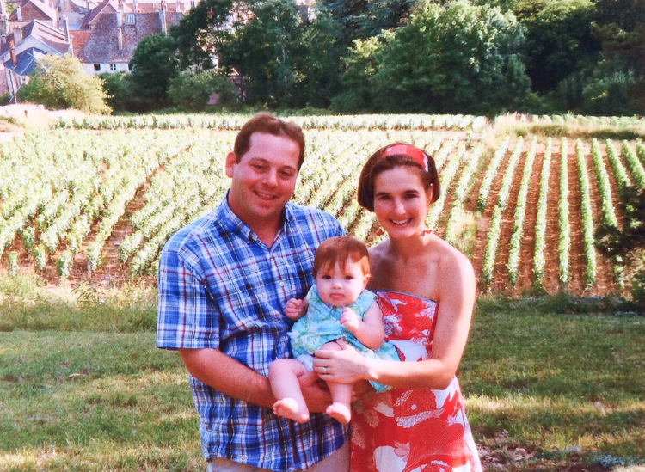
The couple took their daughter, Cynthia, on a trip to the Burgundy region of France.
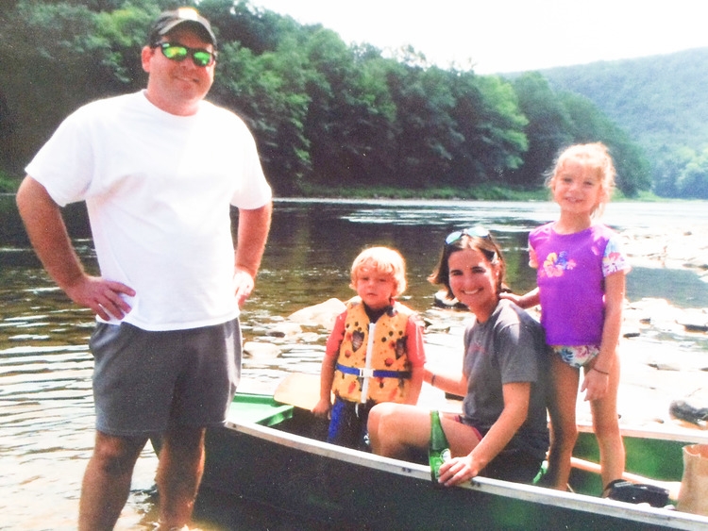
Inez and Stephen with their children Cynthia and Stephen, taking some time off and enjoying family. Even with their business endeavors, family time comes first.

Looking Forward
Inez and Stephen’s new venture, Tarboro Brewing Company, is slated to open this fall. Located right down the street from On the Square, the 10,000 square foot brewery will encompass a large outdoor area with corn hole, ping-pong tables, taps of beer brewed in-house and food trucks. With the help of Tarboro, they received a $200,000 grant from Main Street Solutions, through the N.C. Department of Commerce to jumpstart the business. This will bring in at least eight more full-time jobs at the brewery.
It’s a big undertaking but one that Inez and Stephen feel will contribute to the growth and success of Tarboro. “This town has been incredibly supportive. We have good leadership in this county,” says Stephen. “The people who are living here...are devoted to making sure Tarboro isn’t just another eastern North Carolina town that dies or fades.”
Both Inez and Stephen say that if 9/11 had not happened, they would still be in New York City, most likely working at Windows on the World. But they came out of the ashes to find a new life; not one they ever imagined for themselves, but now one they can’t see themselves without — one filled with fearless risks, unexpected adventures, and a loving, blended family, right where it all began — Tarboro, North Carolina.

FOLLOW ALONG

@BITANDGRAIN
We're making a hard case for #nc #hard #cider at your #thanksgiving this week. Give it a chance, you will like it:… https://t.co/F7iCypttcJ
7 hours ago

Home Stories Events Applause Our Team Contributors Advertise Contact Privacy Policy
Copyright Bit & Grain 2015-2016. All rights reserved.
Click Here to Close & Subscribe Later

